OS & SP
Name : M Ramya Sree Roll No : 2520030094
Practical – 06
Server.c
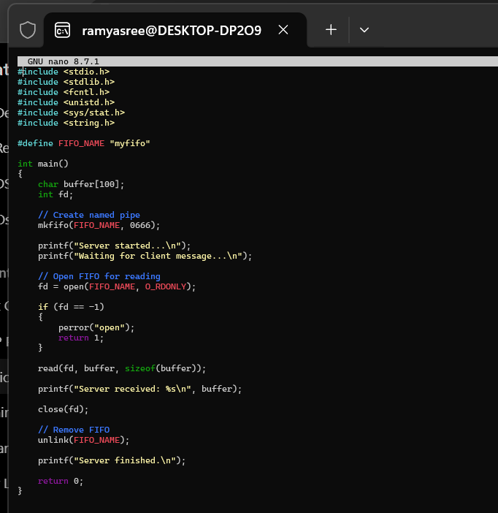
Client.c
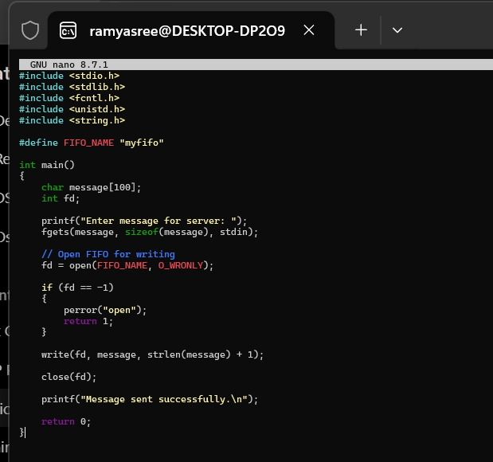

Output :
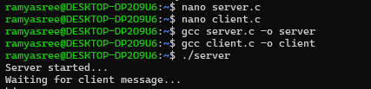
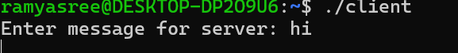
Signals.c
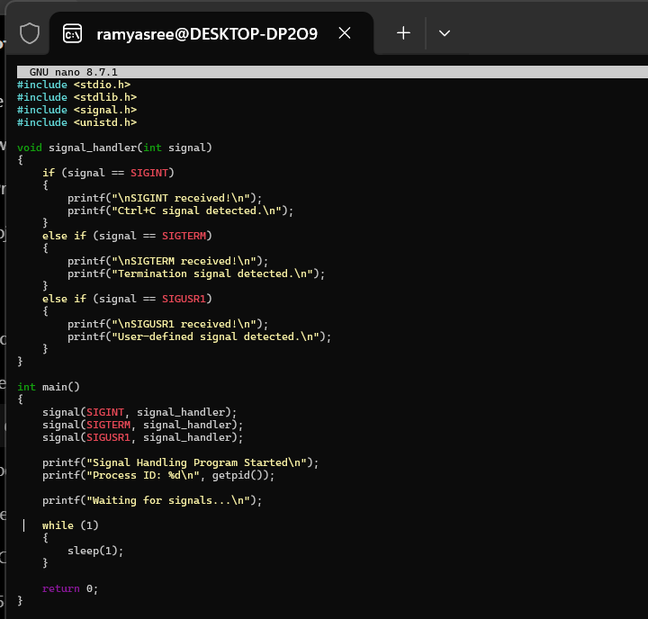
Output :
